Software Requirement Specification

Introduction

Aim of the document
The document aims to present the software system PickyEaters.
Each of the following numbered subparagraph will point out a different characteristic of the system, starting from a general overview of the defined system, its hardware and software requirements, and its competitors – describing both the pros and cons of the system, compared to the system competitors.
Later in the document, each paragraph will present some functionalities of the system, starting with three user stories, then three functional requirements, and eventually the use case diagram.

Overview of the defined system
PickyEaters is a software system developed for all the picky eaters who struggle to find something to eat or drink when not eating at home.
The system expects three types of users:
- the base user, who will be called Pickie, interested in finding places to eat, by themselves or with their picky friends;
- the business owner user, who will be called Restaurateur, interested in promoting their business – a restaurant, pub, cafe, or similar;
The Pickie will be able to find places where they can find meals that suit their diet, by declaring ingredients they don’t like and their dietary regimen (e.g.: halal, kosher, vegetarian, vegan, pregnant, etc…).
On the other hand, the Restaurateur shall register their business information into the system, providing also their menu, containing each dish and its ingredients. They are also responsible for maintaining updated menu information.

HW e SW requirements
The application is platform-independent and can be executed on any system where a Java Virtual Machine (JVM) is available. Two variants are provided: a GUI version, intended for systems with a graphical desktop environment, and a CLI version, which can be executed on headless systems without graphical capabilities.
The system can also run with two mode: a demo version where all the system will live in local RAM, so will be no persistency layer, and a full version that requires a PostgreSQL database (local or remote).

Related systems, Pros and Cons
PickyEaters is a unique system as it fills a gap in the food service market that is ignored by related systems, such as Tripadvisor, JustEat, and Glovo.
It is similar to Tripadvisor as its purpose is not to order and deliver food, but to show places where to eat out.
Yet it is also similar to JustEat and Glovo as it only concerns restaurants, pubs, cafes, and similar – not hotels, flights, etc… –, and offers an insight into a restaurant menu, showing dishes.
The potential of the idea behind PickyEaters cannot, unfortunately, be fulfilled because of the obvious lack of a corporate-like structure, funds, expertise, and time. This leads to a long list of cons that could, however, be easily mostly crossed out if only the system were developed in a proper environment; that list includes:
- Strong, prominent competitors;
- Simplistic and not captivating design of UIs;
- Simplistic functionalities;
- Underdevelopment of cybersecurity measures;
- Possibility of noncompliance with legal requirements;
As it comes to exploring the pros, it should be highlighted that:
- The system is wholly designed and developed ex novo: the software development process follows disciplined, uniform, and recent practices;
- There is room for adding, refining, and bettering functionalities;
- In the current market, where inclusion and customization are being more and more seen as priorities, no other similar system offers the possibility to customize and filter results at such a fine grain.

User Stories
  - As a Pickie, I want to search restaurant without ingredients that I don’t like, so that I can find a place to eat.
  - As a Restaurateur, I want to modify my menu (dish and ingredient of dish), so that Pickies can find my restaurant.
  - As a Restaurateur, I want to modify my restaurant details, so that Pickies can contact me.

Functional Requirements
  - The system shall provide the Pickie with the selection of disliked ingredients.
  - The system shall provide the Restaurateur with the selection of ingredients for their dishes.
  - The system shall provide the Pickie with a list of compatible restaurant based on the eating preference.

Use Cases

Overview Diagram
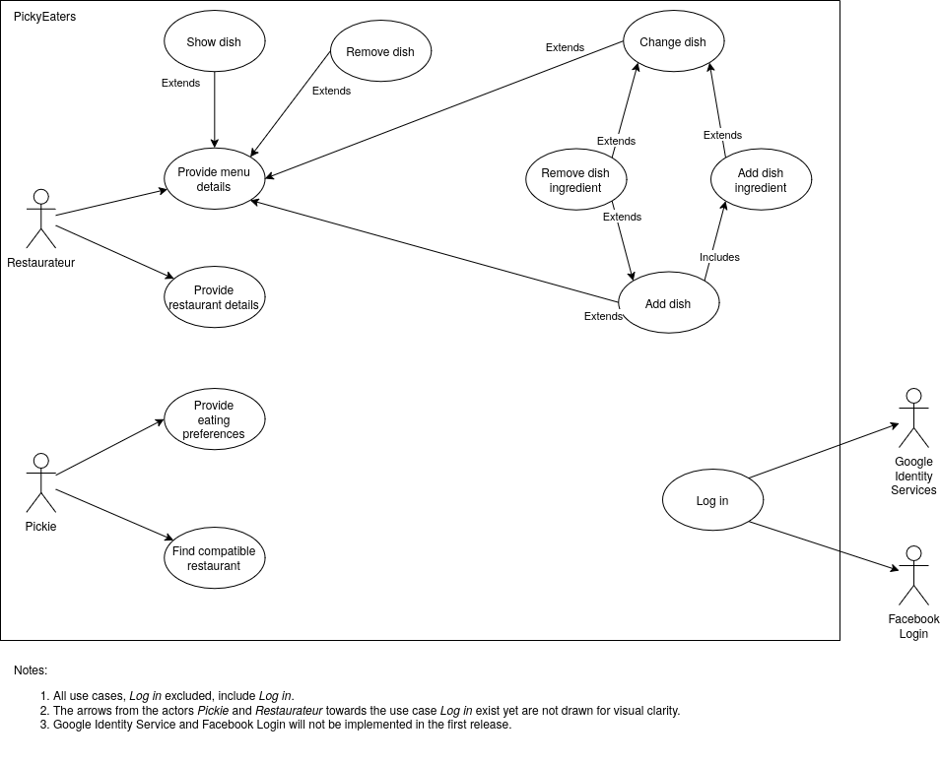

Internal Steps
Name: Add dish
- The Restaurateur requests to add a dish to the menu.
- The System prepares a blank form.
- The System fetches dish types.
- The Restaurateur types the dish name and the dish description, one dish type, and adds an ingredient* or Remove an ingredient* per time.
- For each ingredient selection, the System presents the ongoing list of selected ingredients and consequent allergens.
- The Restaurateur indicates the operation is complete.
- The System saves the dish.
- The System display a success message.
Extensions:
3a. Cannot fetch: The System notifies the Restaurateur and terminates the use case.
5a. Same ingredient selected more than once: The System removes the double from the dish ingredient list.
6a. No ingredient selected: The System notifies the Restaurateur and require to add atleast an ingredient.
6b. No name selected: The System notifies the Restaurateur and require to insert dish name.
6c. Duplicated name selected: The System notifies the Restaurateur and require to insert alternative dish name.
6d. No dish type selected: The System notifies the Restaurateur and require to add a dish type.
7a. Error while saving: The System notifies the Restaurateur and terminates the use case.
Adds an ingredient*: It refers to the use case Add ingredient.
Remove an ingredient*: It refers to the use case Remove ingredient.

Storyboard

1. Add dish
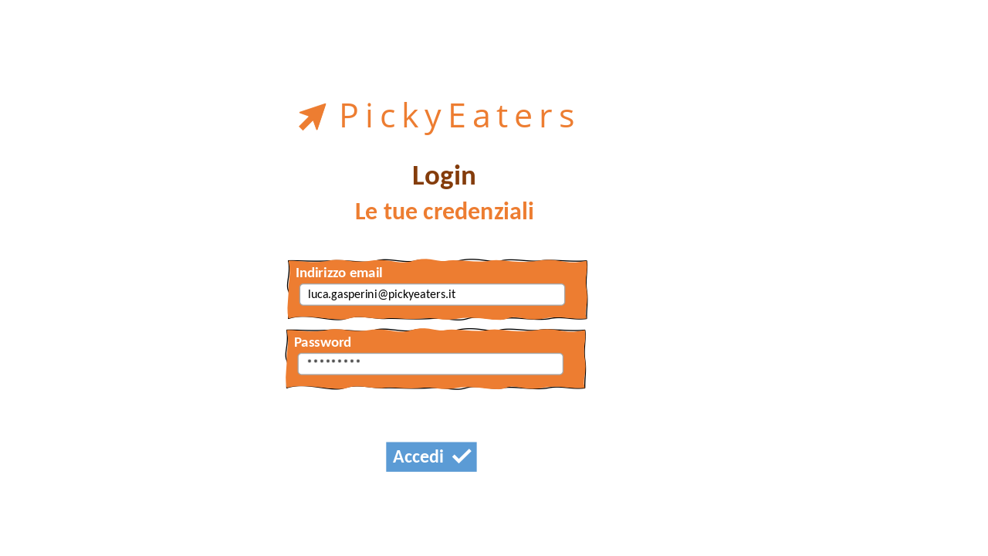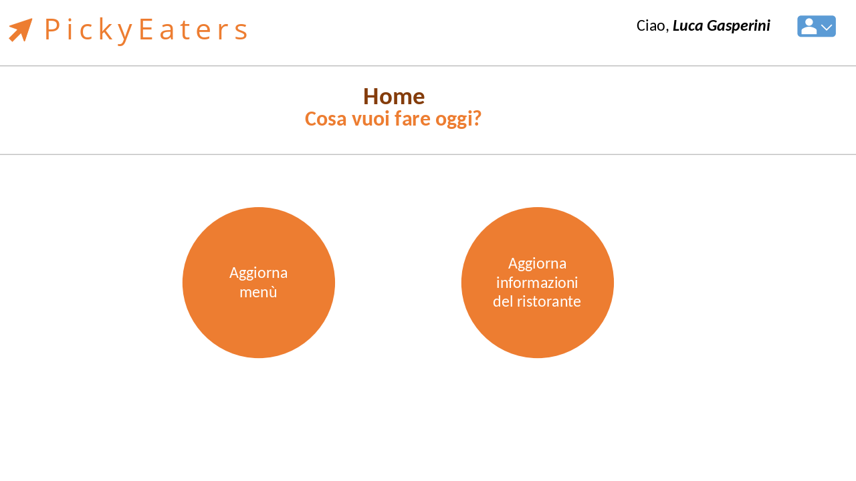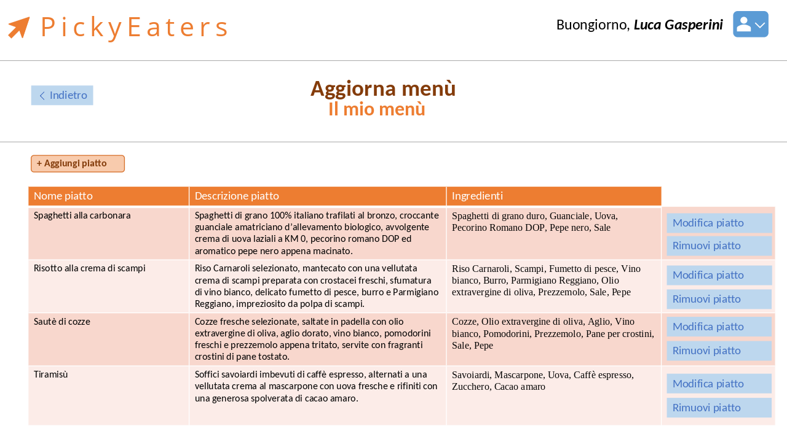
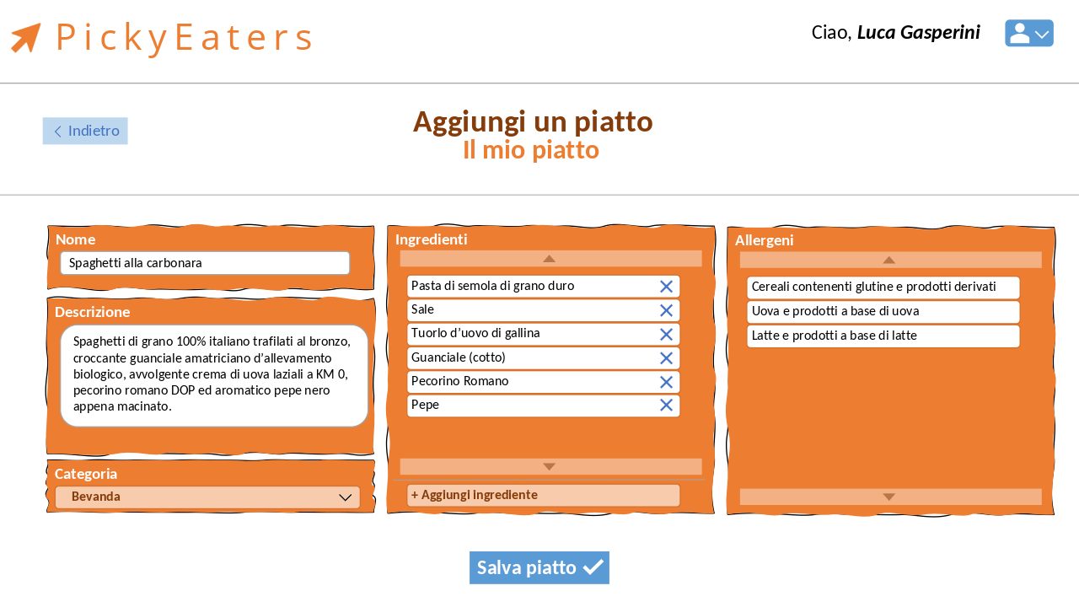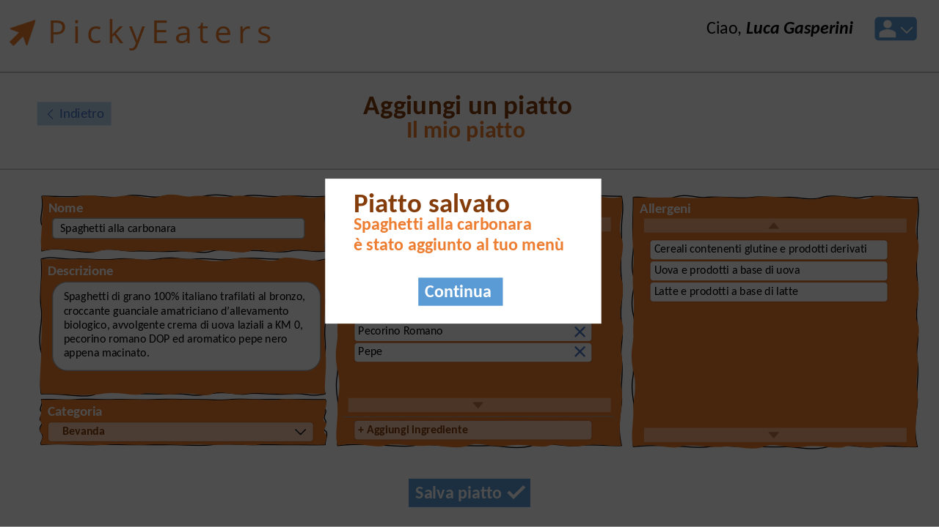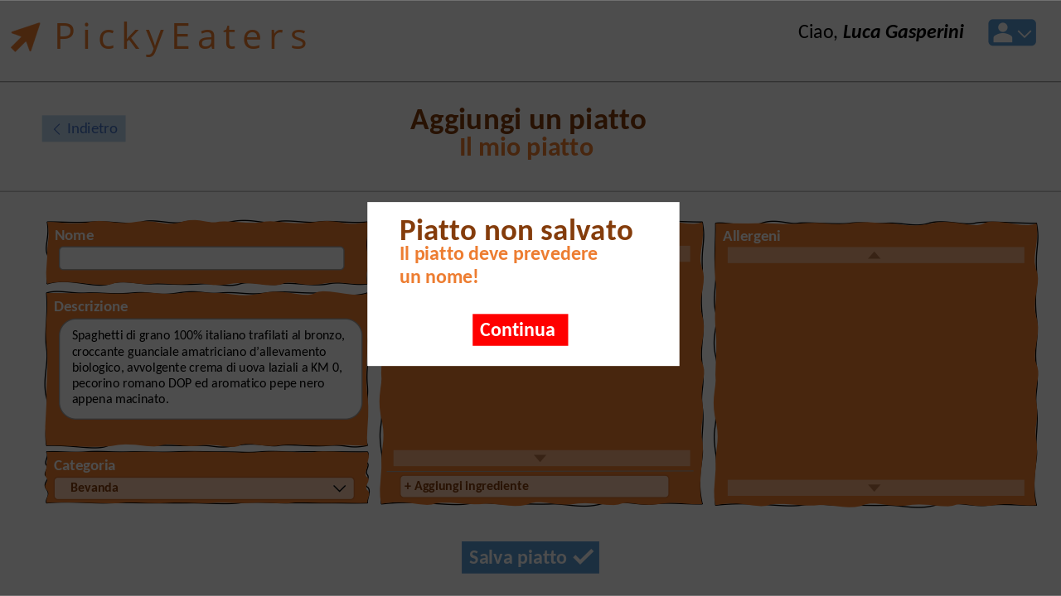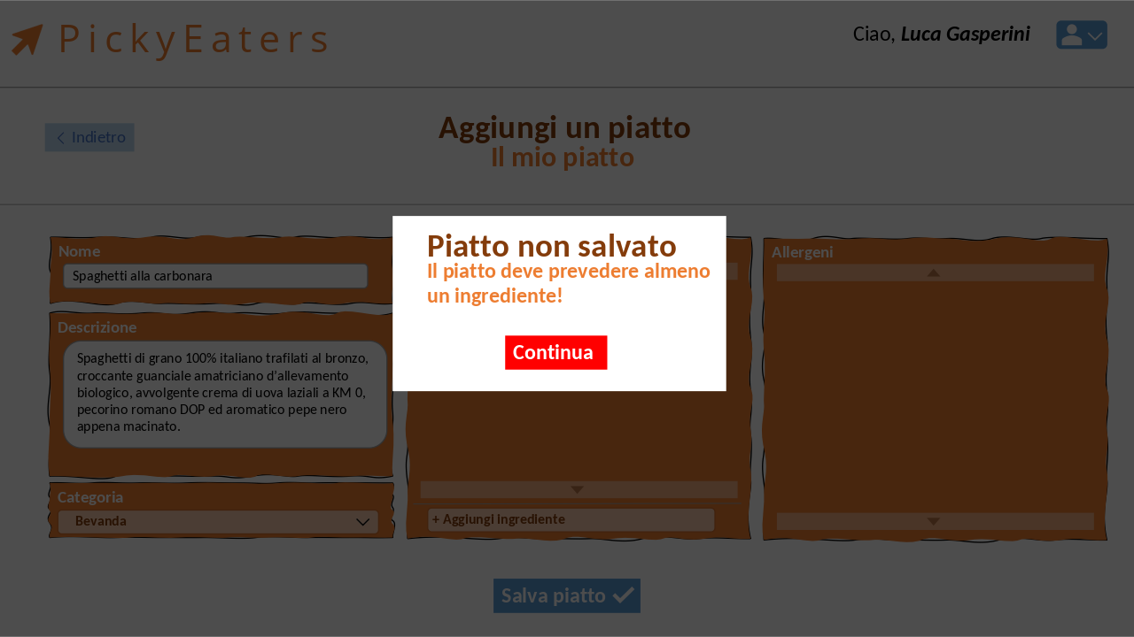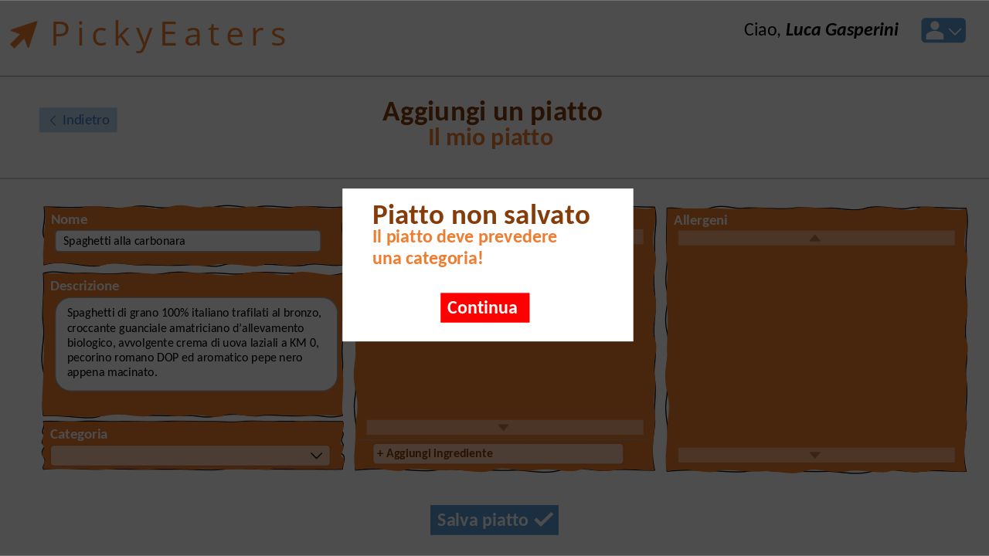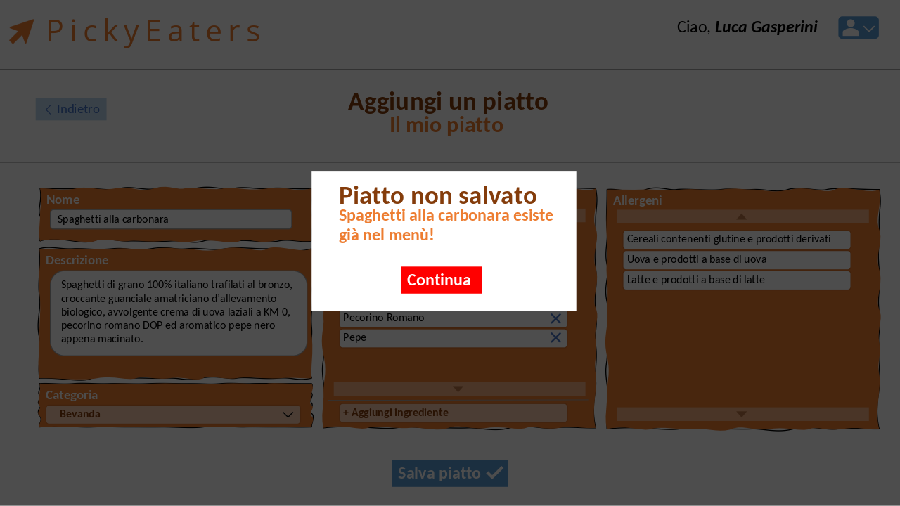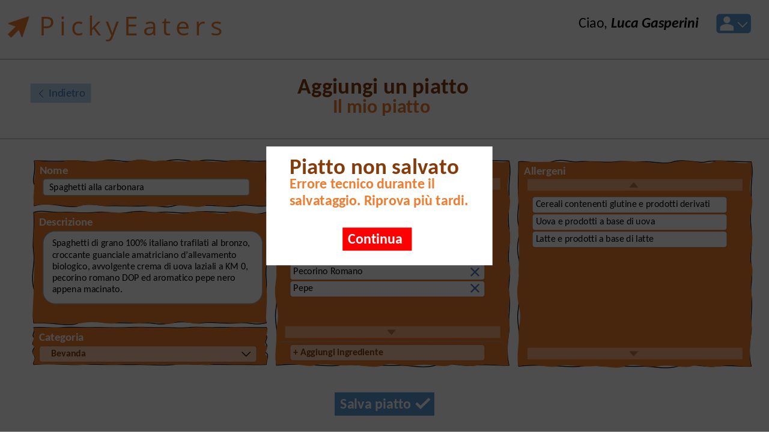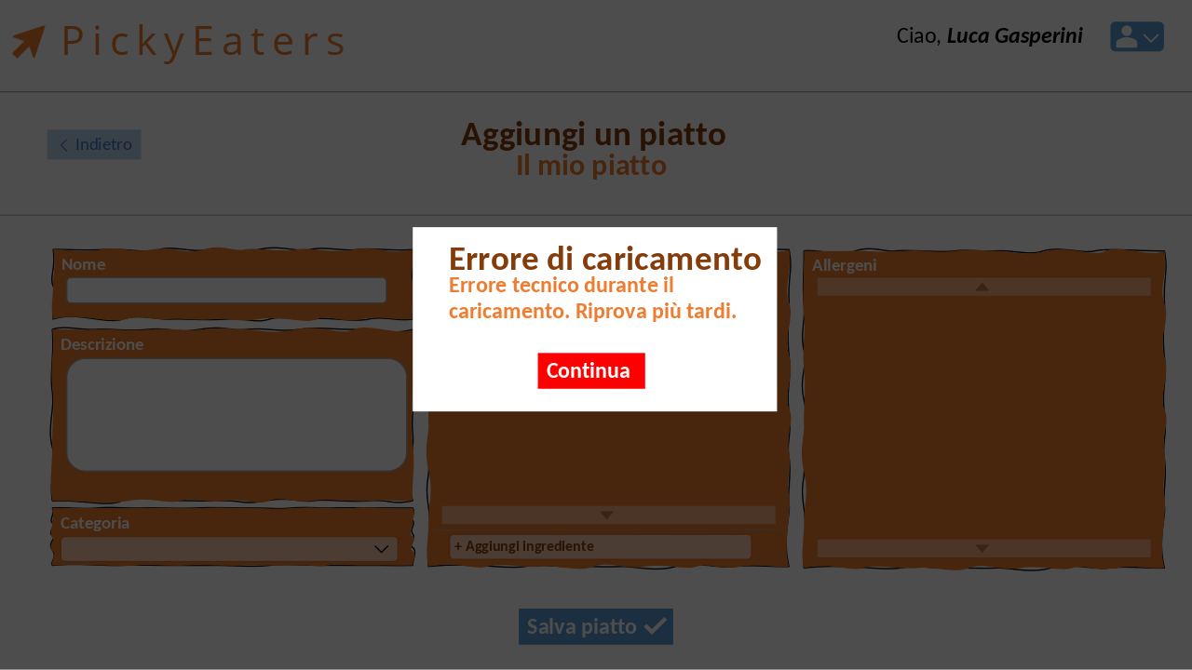

2. Find restaurant
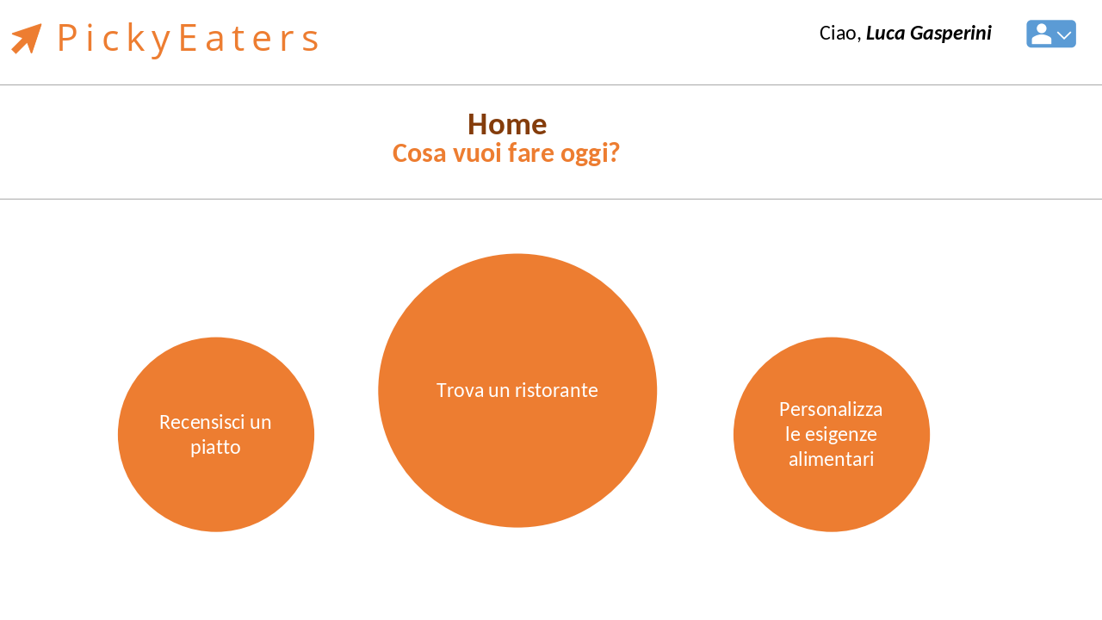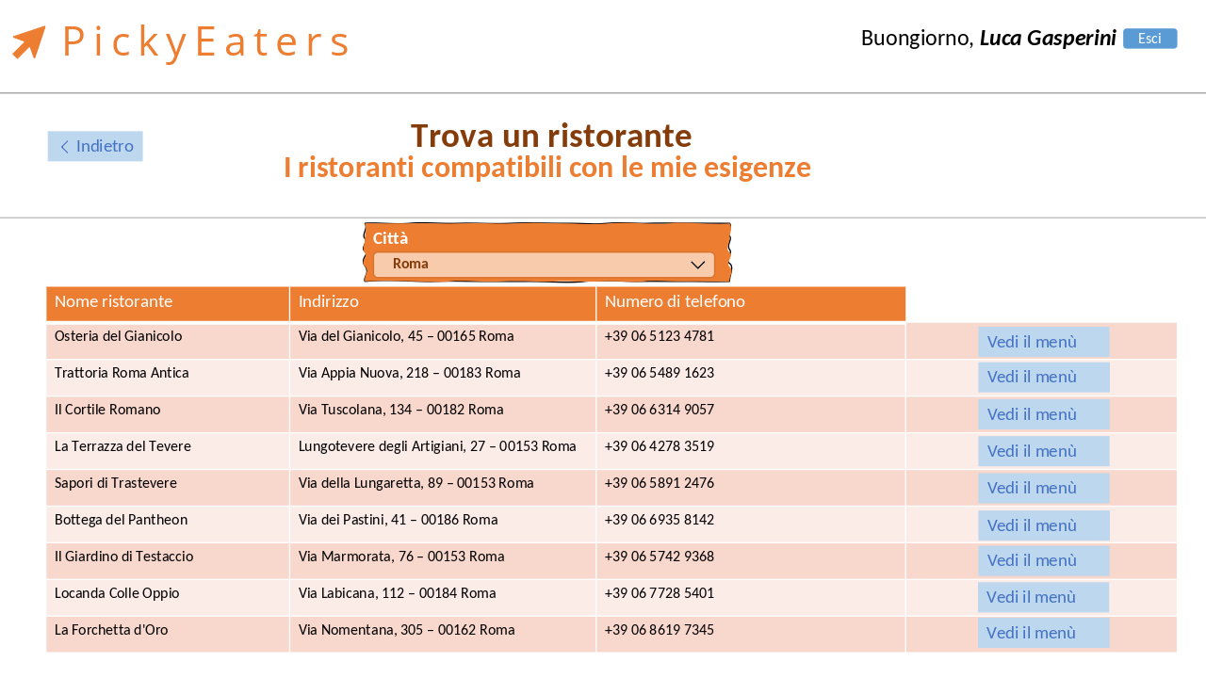
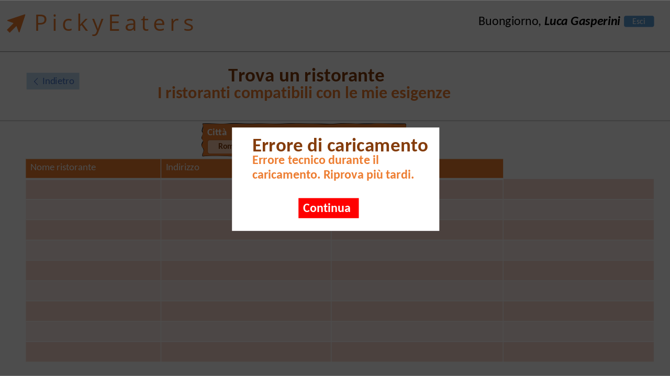
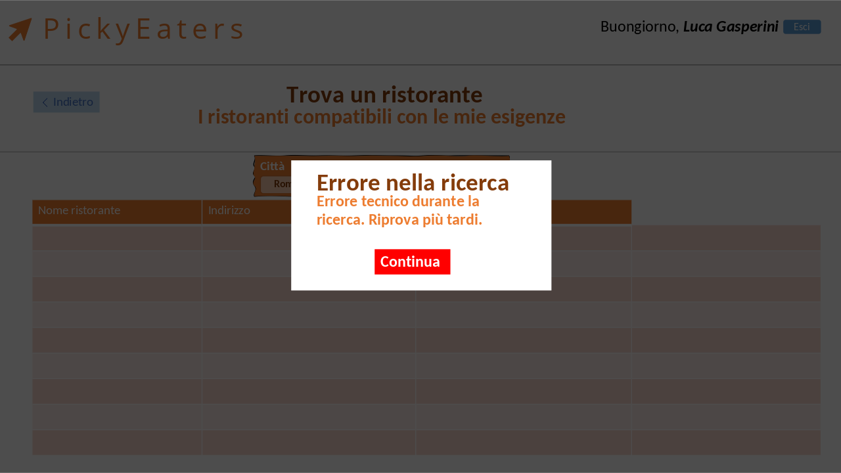
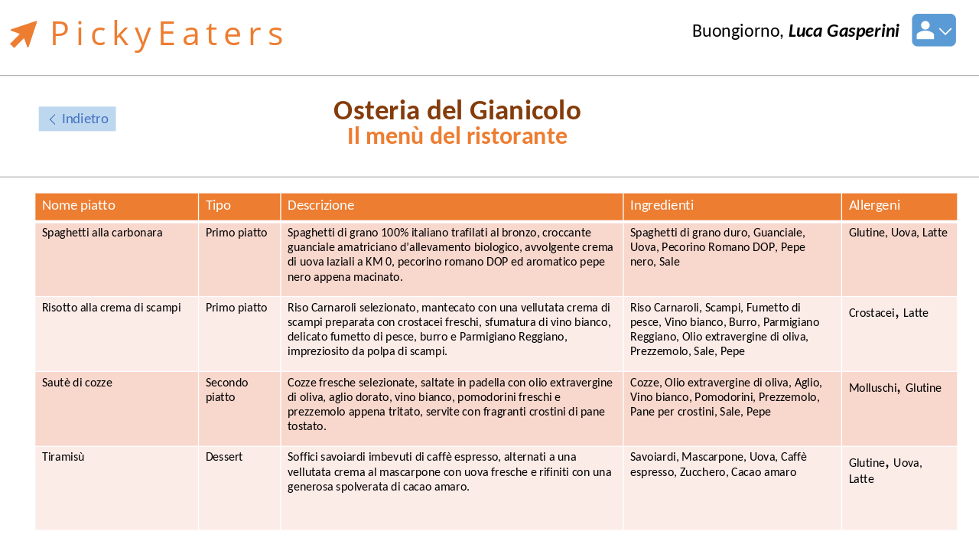
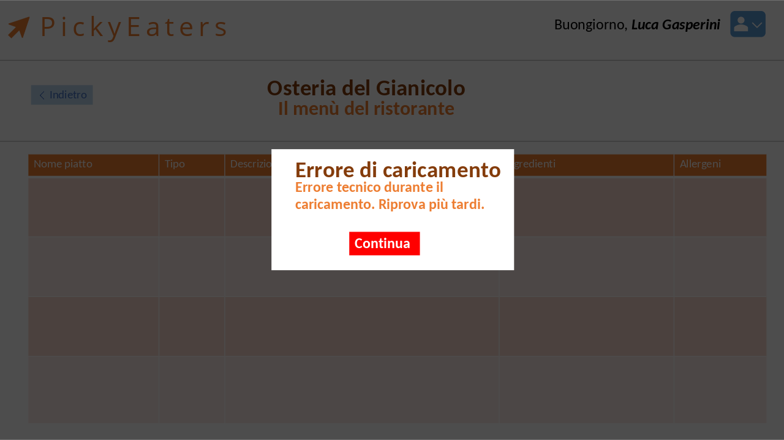
Note:
- Custom graphic for error message box will not be implemented in first release.
- Orange box on fields will be not implemented in first release.
- The welcome box on the application header will contain only the user's firstname.
- Show menu restaurant in find restaurant will reuse show menu graphic of restaurateur in actual implementation.
- All text displayed may vary depending on the actual implementation or language localization of the application.
- Find restaurant form will contain dish type needed by the Pickie as a checkbox.

View Of Participating Classes
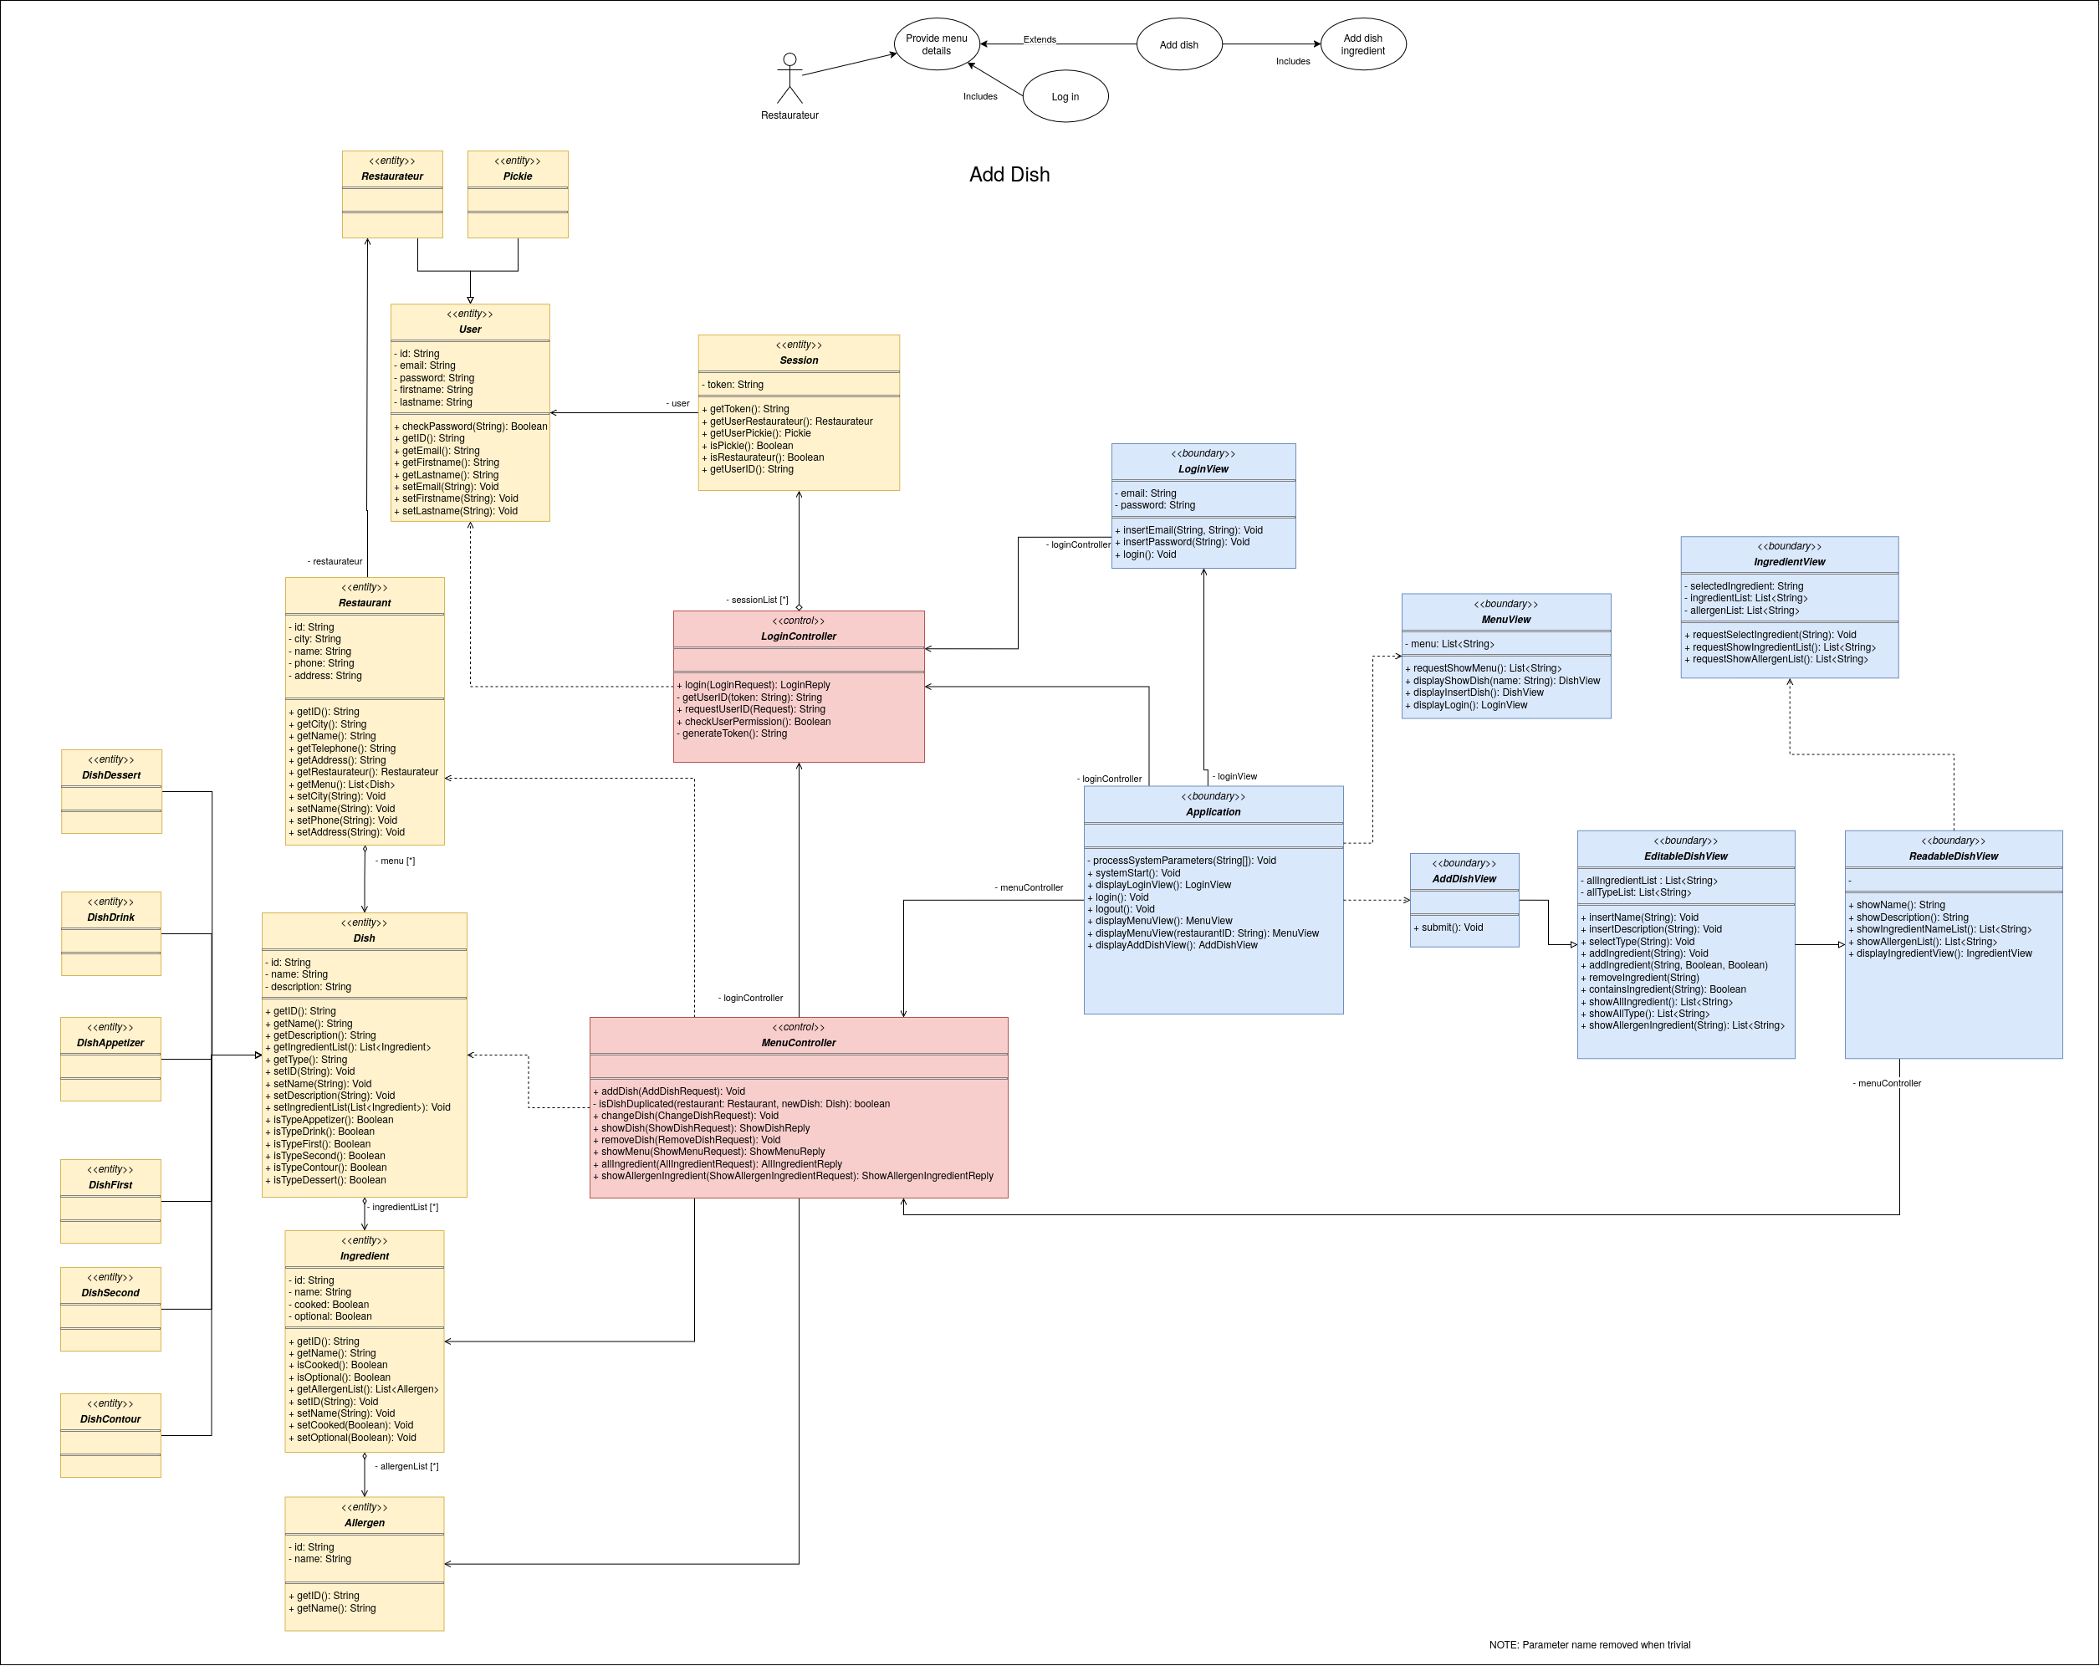Note: The diagram represents a simplified version compared to the implemented code, so it’s useful for visualizing the overall structure.

Class design

Full schema
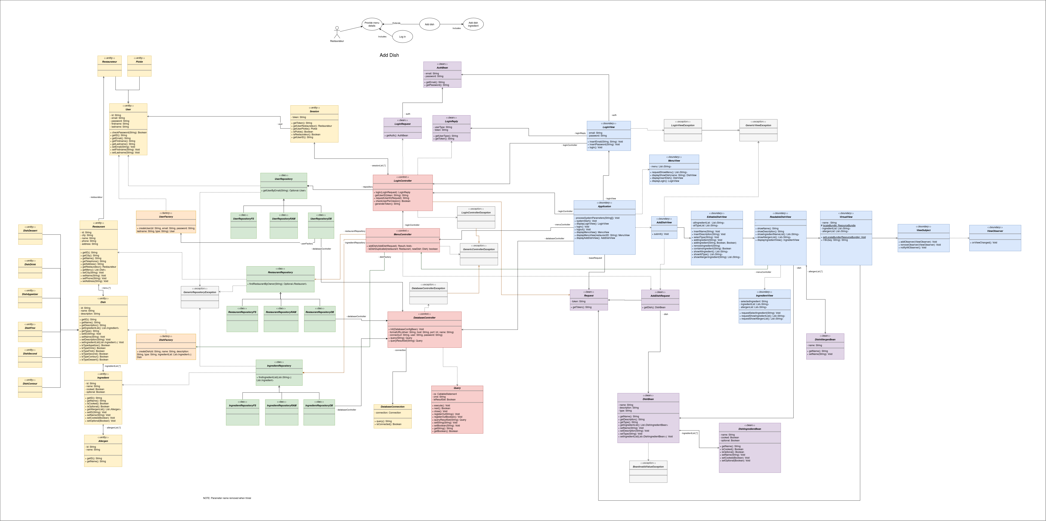

Bottom-left magnification (Model-Factory-DAO-Controller)
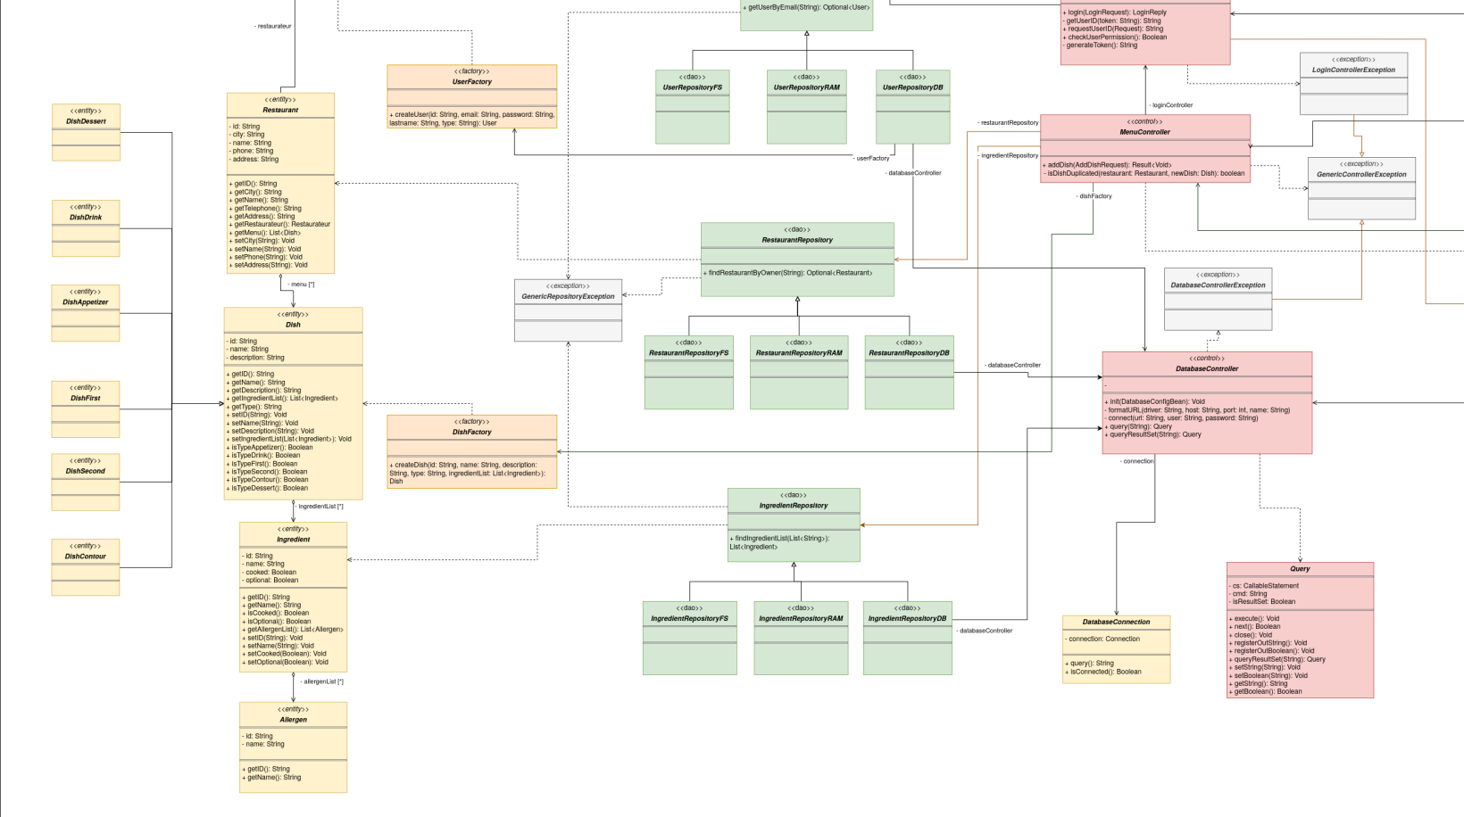

Top-left magnification (Model-Factory-DAO-Controller-Bean)
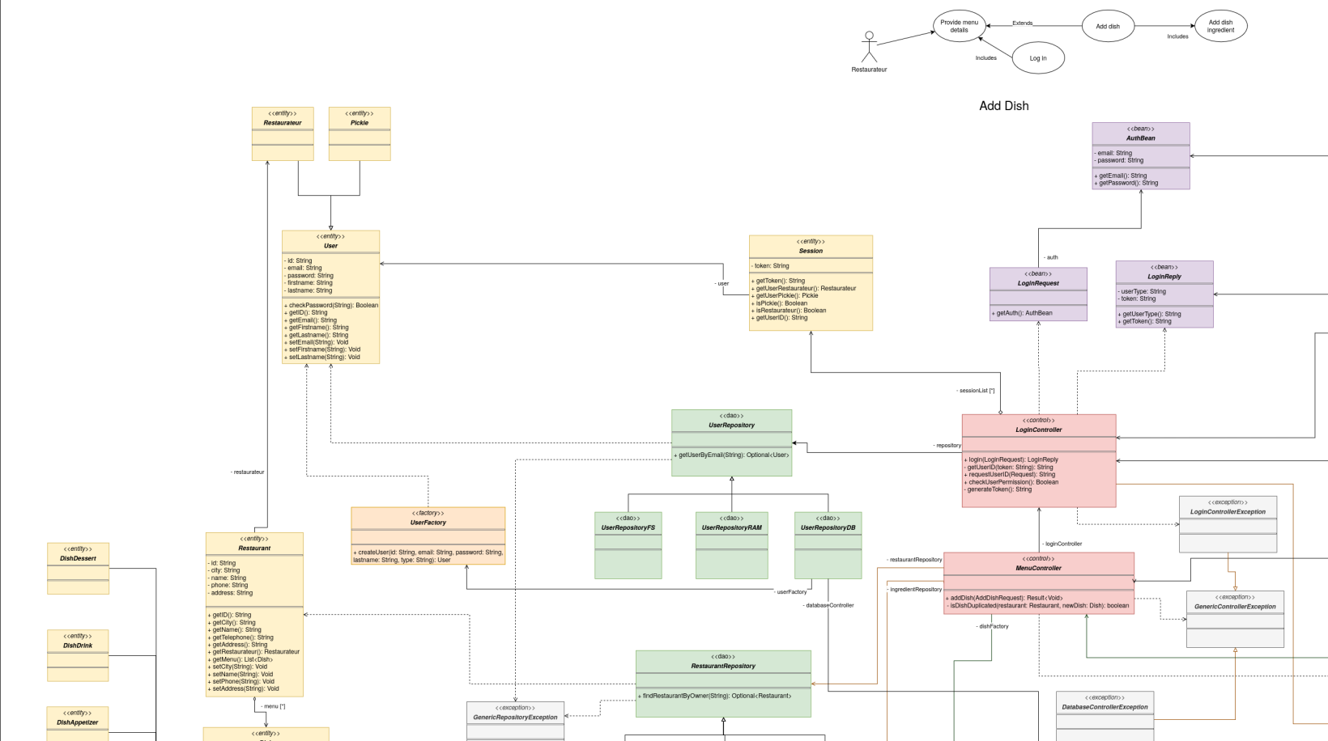

Top-right magnification (View-bean)
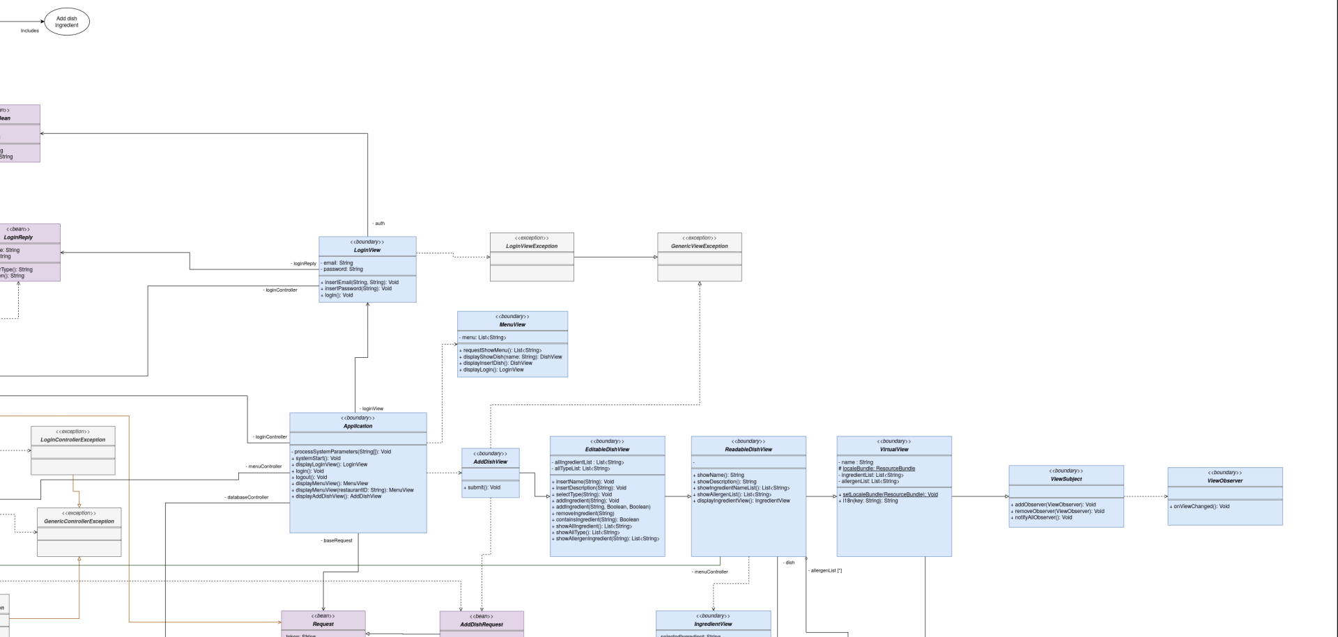

Bottom-right magnification (Controller-View-Bean)
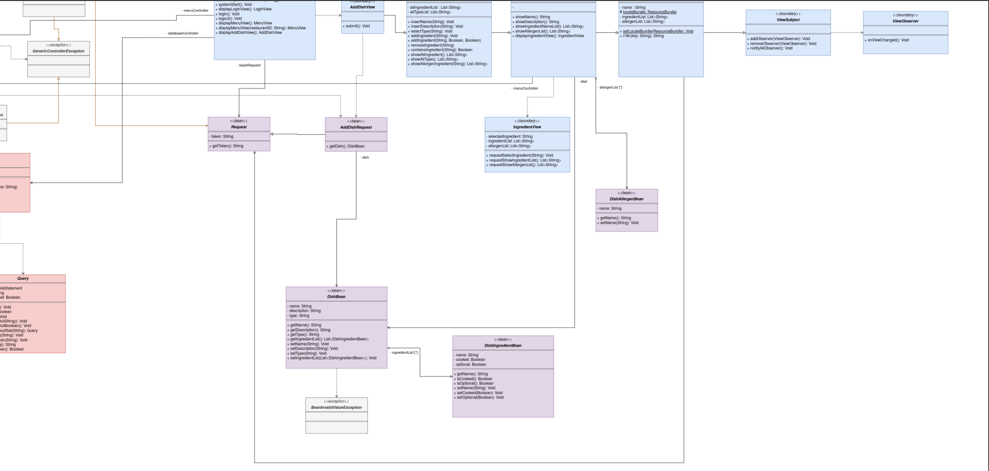
Note 1: The diagram represents a simplified version compared to the implemented code, so it’s useful for visualizing the overall structure.
Note 2: Repository are implemented as interface, so when they do not have the dependency, it’s useful to indicate that the implementations of the interfaces depend on the class.

DESIGN PATTERNS
In the context of the system, the Factory pattern has been implemented to manage the creation of different types of objects in a centralized and structured way. The main purpose of this pattern is to separate the object creation logic from the classes that use those objects, reducing dependencies and improving the maintainability and extensibility of the system.
In particular, the DishFactory class has been implemented to handle the creation of the different types of Dish objects used within the application. Depending on the required category, the factory is responsible for creating the appropriate object without requiring the client classes to directly instantiate a specific implementation.
The DishFactory manages the creation of the following dish types: DishAppetizer, DishFirst, DishSecond, DishContour, DishDessert, and DishDrink. In this way, the logic related to the creation of dishes is centralized inside the factory, making it easier to introduce new dish categories or modify the existing ones without significantly affecting the rest of the system.
The same approach has been adopted for the management of users through the UserFactory. This factory is responsible for creating the appropriate User object according to the type of user required by the application. In particular, the system currently distinguishes between the Pickie and Restaurateur user types. Therefore, the client classes do not need to directly know which concrete user class has to be instantiated, since this responsibility is delegated to the UserFactory.
The use of these factories provides a clearer separation of responsibilities and avoids spreading object creation logic across different parts of the application. Furthermore, it makes the system more flexible, since additional types of dishes or users can be introduced by extending the corresponding factory logic.
Moreover, other design patterns have been used in specific parts of the system. In particular, the Observer pattern has been adopted for the dynamic management of graphical interface elements in relation to the bean classes. Through this approach, the graphical components can react to changes in the state of the beans and update their content accordingly, without introducing strong dependencies between the graphical interface and the underlying data model.
Therefore, while the Factory pattern represents the main solution adopted for the creation of Dish and User objects through DishFactory and UserFactory, respectively, the use of the Observer pattern contributes to maintaining a more dynamic and loosely coupled interaction between the application beans and the graphical interface.

Activity Diagram
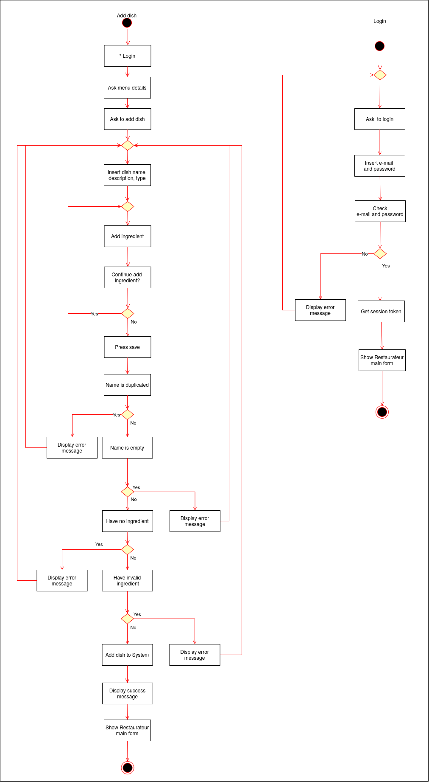

Sequence Diagram
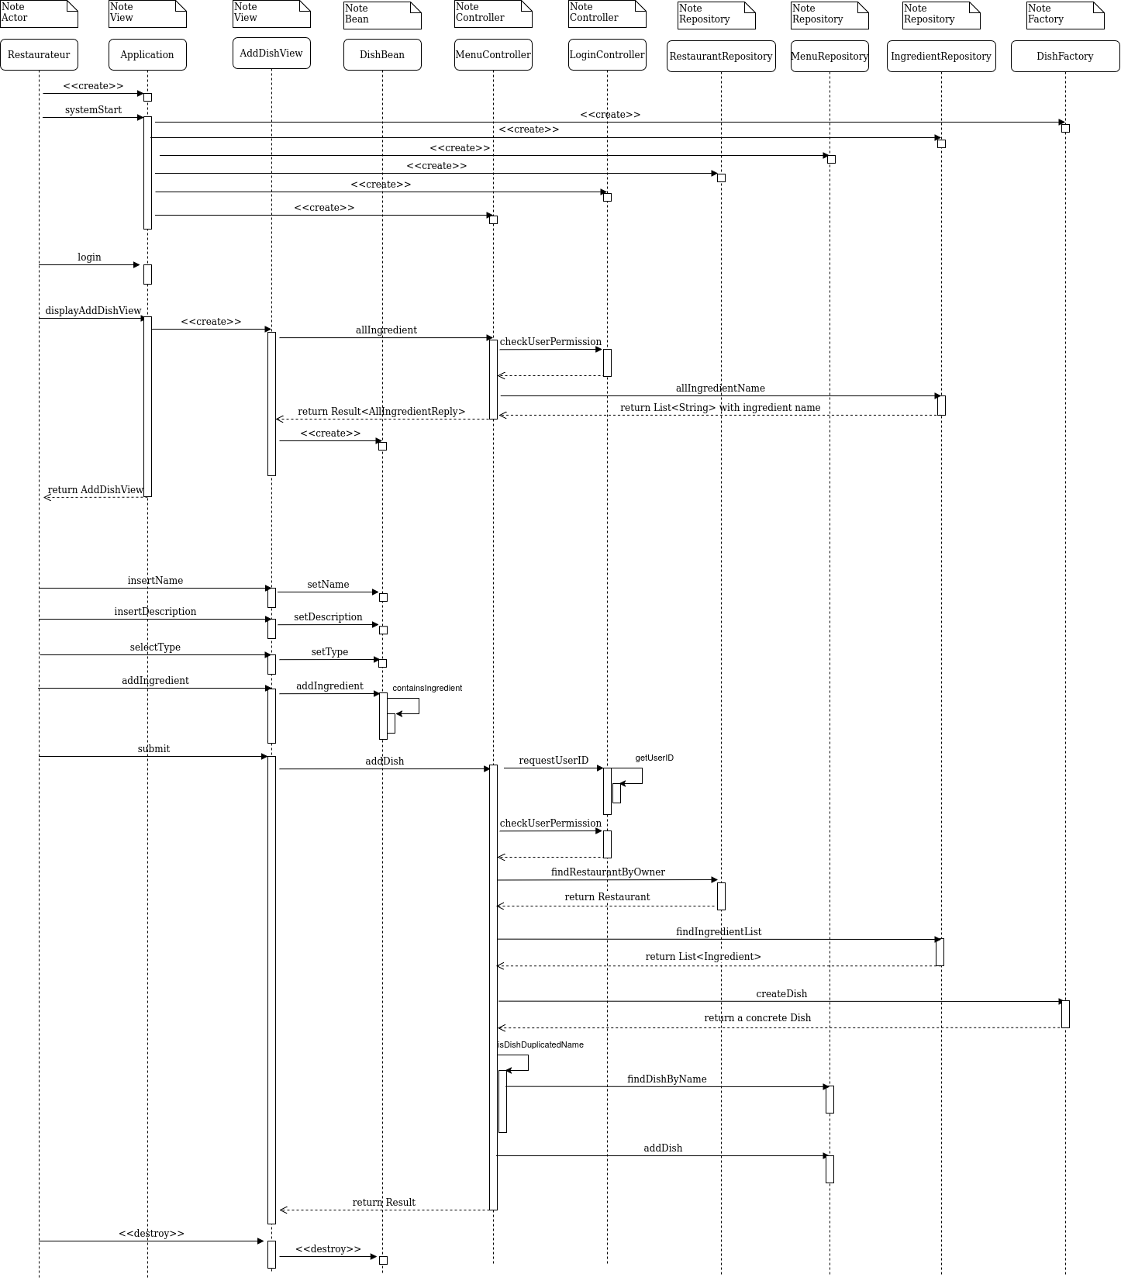

State Diagram
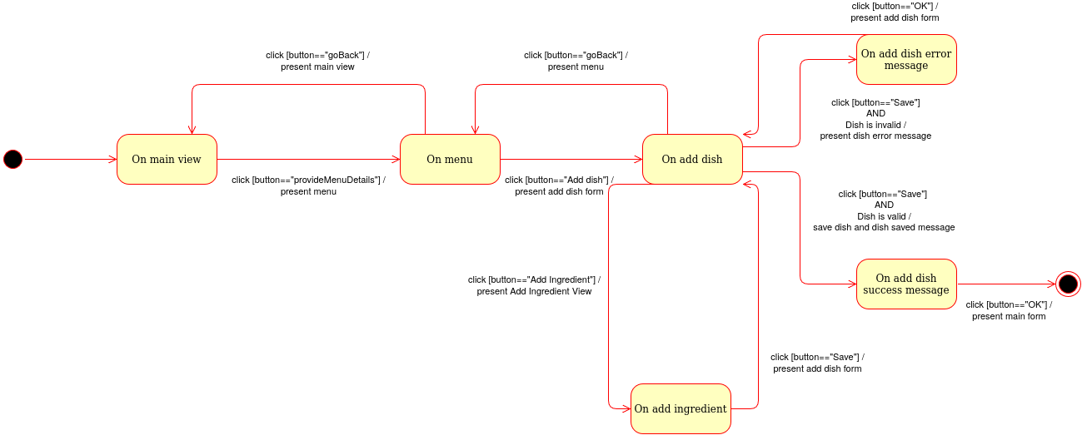

Testing
For the testing phase, I have developed the following test classes, following the Use Case Diagram:
- LoginFSTest
  - login(): used to test filesystem DAO
- PickieTest
  - showEatingPreference()
  - editEatingPreference()
  - findRestaurant()
- RestaurateurTest
  - showRestaurant()
  - editRestaurant()
  - showMenu()
  - addDish()
  - showDish()
  - changeDish()

Exception
There are various classes for exception handling in the project, the most important ones are:
- GenericViewException
- GenericBeanException
- GenericControllerException
- GenericRepositoryException
- GenericFactoryException
They are, in fact, generic, and indicate an error at a certain level of the system, which may be passed on to the next higher level or resolved once it has been catch.

SonarQube
To check the correct behavior of this project, it was used SonarQube system. This system points out the possible bugs, possible vulnerabilities, and review that the functions are well implemented. You can check the results of the project in the following link:
https://sonarcloud.io/project/overview?id=lucagasperini_ispw

Public Git repository used:
https://github.com/lucagasperini/ispw
The video is on the documentation section of the repository.

